Created by

Muhammad Abuzar FA25-BCS-051
Bilal Ahmad FA21-BCS-002

ASCII CAr racing game

Table of Contents
1.Introduction -------------------------------- 2
2.Objectives ---------------------------------- 3
3.Flow Chart ---------------------------------- 4
4.System Requirements -------------------- 5
5. How to Play -------------------------------- 5
- Gameplay Conrols -------------------------- 7
- Game Rules ---------------------------------- 7
6.Functions ----------------------------------- 10
7.Work division table ------------------------ 12

Introduction:
It is a console based game developed in C++. Its name is “ASCII Car Racing”. The game is based on simple ASCII characters to depict cars, lanes and obstacles. This game allows two players to play at the same time and compete. The players move their cars left and to the right to avoid falling obstacles. The score of both players continues to increase as long as they do not collide with the obstacle. The game will be terminated when both players collide both players collide and a winner will be announced.
This project tells us about important programming concepts such as:
- Arrays
- Loops
- File Handling
- Functions
- Conditional Statements
- Basic Game Logic
- Real time keyboard input
- Console cursor movement and screen clearing

Objectives:
The main goals set out to achieve from this game were:
- Making Car Move and Dodge: To figure out how to let the players control the car position and allow them to move it left and right to avoid incoming obstacles rolling down the screen.
- Simultaneous Two-Player Gameplay: To get the two players racing on the same screen at the same time, battling it out for that top spot on the leaderboard.
- Collision Detection: To accurately tell when someone's ASCII car smashes into an incoming obstacle and then make the car stop.
- High Score Saving: To implement file I/O operations to load and save the highest score achieved in the game, making the players to surpass and achieve that high score.
- Game Loop Management: To design and implement an efficient game loop that handles input from the player about car position, game logic (movement of car and obstacles random generation), and then drawing the car and board effectively.

Flow Chart:

System Requirements:
This game requires very low system requirements because it is a console based game.
Operating System: This game can only run on windows operating system.
Compiler: This game runs only on compiler. It can be any C++ compiler such as Visual Studio code or Code Block etc.
Processor/Ram: Any modern processor and minimal amount of RAM (less than 2MB of working memory).

How to Play – Complete User Guidelines:
Game Setup: First open your compiler in which you want to execute the code. Compile and then run the code.
Ready Check: When code executes an interface will come which will ask Player 1 press ‘y’ or ‘Y’ if ready and Player 2 press ‘y’ or ‘Y’

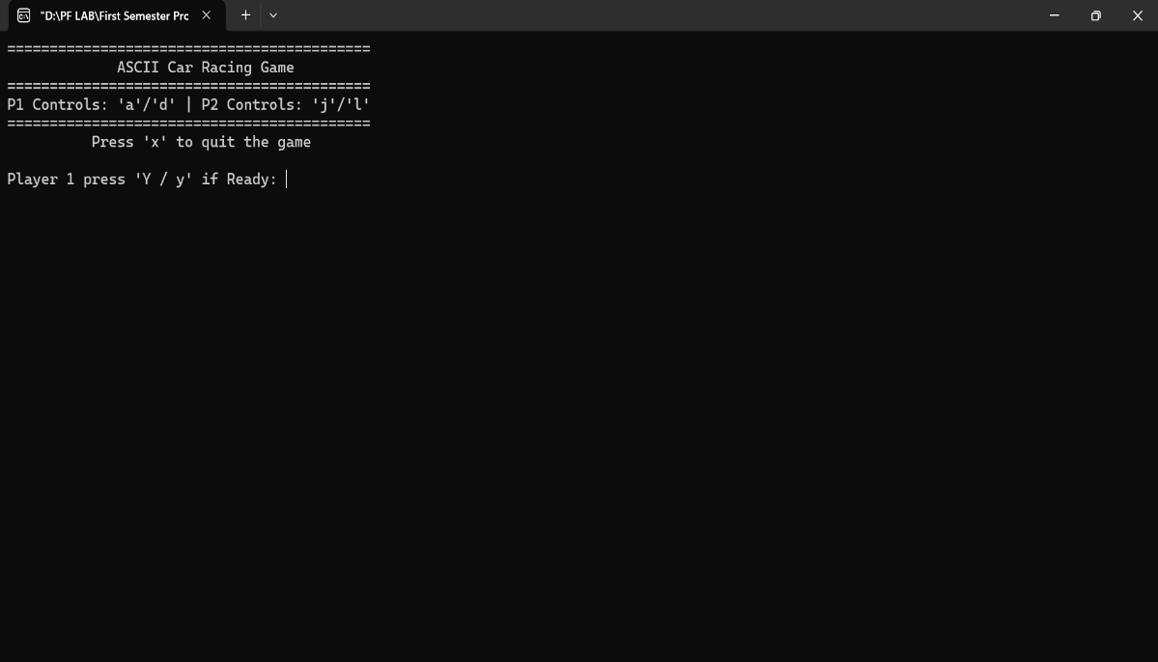

Game Start: When both are ready then Game starts.

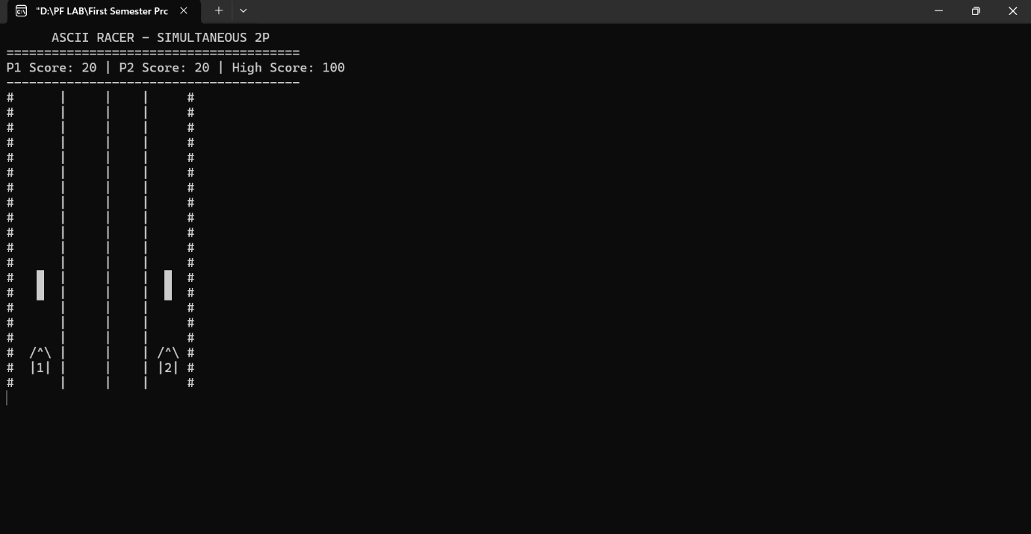

Gameplay Controls:
The game provides control for both players and the players can press their control keys simultaneously.

Player | Action | Key
Player 1 | Move left | Press ‘a’
 | Move right | Press ‘d’
Player 2 | Move left | Press ‘j’
 | Move right | Press ‘l’
Any Player | Quit the game | Press ‘x’

Game Rules:
Avoiding Obstacle: The goal is to dodge the incoming obstacles by moving your car to left or right. Like in this picture player 2 car moves to left to dodge to obstacle.

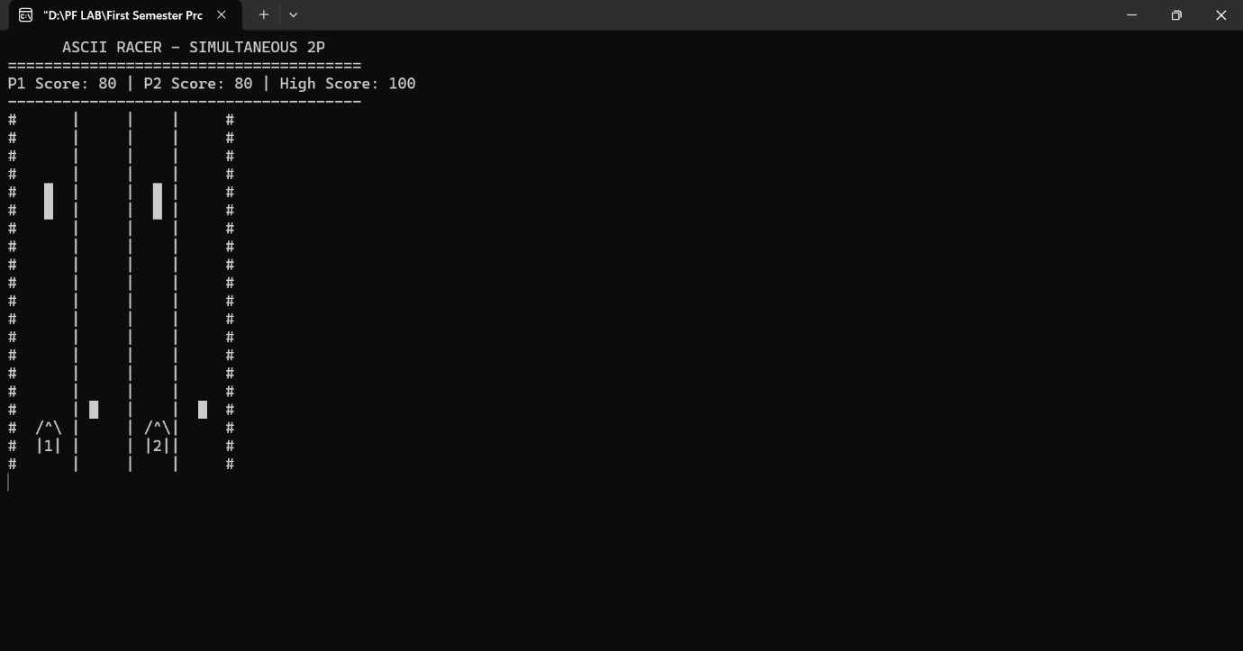

Car Crash: If you are unable to avoid the obstacle and car crashes into the obstacle, your car is marked as crashed. A crashed car is displayed by ‘X’ at the point of collision with obstacle. A crashed car cannot move or score points.
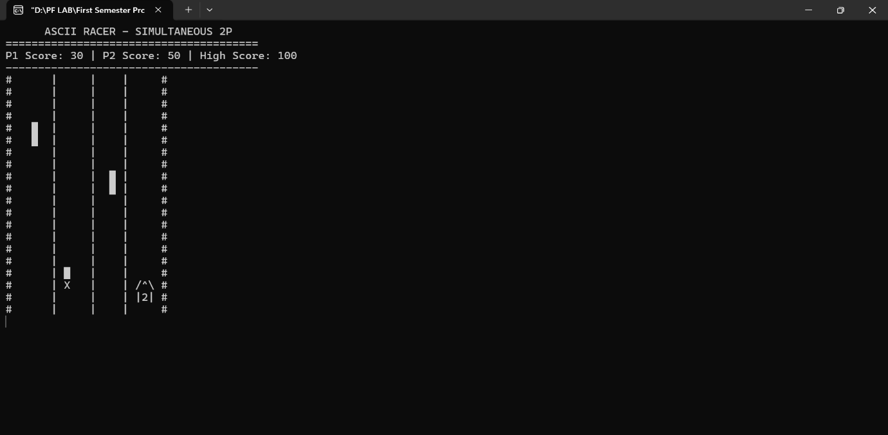

Score: Everytime a new obstacle is generated and player dodges it successfully the player score is increased by 10 points.
Game end: The game only ends when the cars of both Player 1 and Player 2 have crashed.
Winner: The player with the highest score becomes the winner of the game.
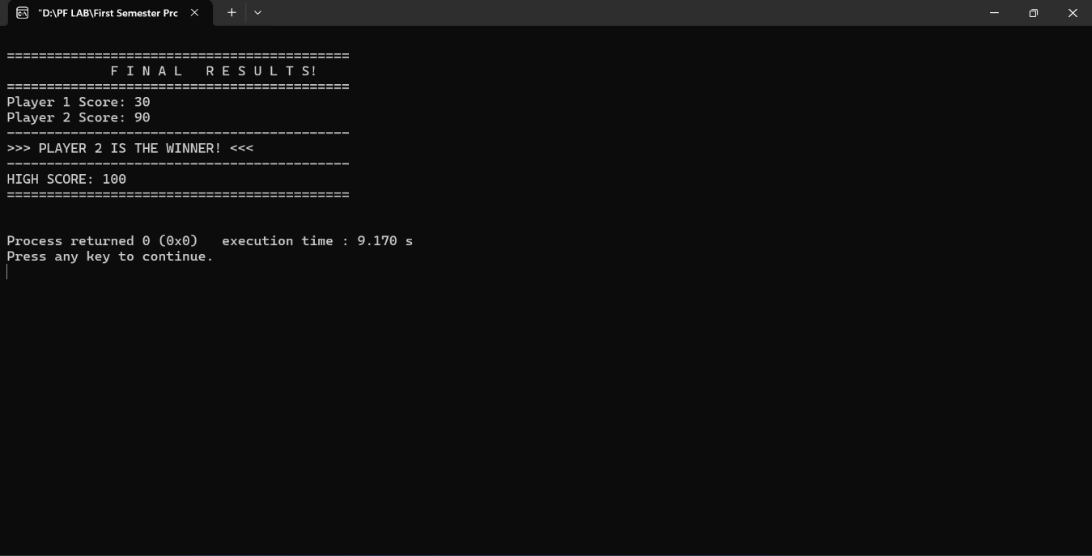

High Score: The maximum score achieved between the two players is compared with the previous high score made and it is saved as the new high score if it is greater than the previous high score.

Functions in Game Code:

- void load_highscore();
This function loads high score from file “highscore.txt”. If file does not opens then sets high score to zero.

- void fullClearScreen();
This functions just clears the whole screen.

- void save_highscore();
This function save new high score. First checks the maximum score between two players and set the new high score to maximum score.

- void game_board_setup();
This function basically draws the game board like the lanes and the outer borders of the game. It also sets the initial position of cars. Moreover, it sets the frame count and score to zero. Player cars crashed is set to false in this function.

- void player_input();
This function gets the input from the user whether to move the car to left or right if the car is not crashed. It takes input without stopping the program for input.

- void draw_car();
This function draws the car on the gameboard. Then removes the car at the end of functions so that it can draw car on new position according to user input.

- void game_logic();
It checks if car1 and car2 is crashed or not. If crashed sets car1_crashed or car2_crashed to true. Then it moves obstacle down as well as generates the obstacle at different positions and increase score by 10 every 6 frames. Then remove obstacles when they reach the end of the board or lane. Also sets game_over to true if both cars have crashed.

- void moveCursorToTop();
This function just moves the cursor to top and then whatever is displayed will be overwritten.

Work Division Table:

Work | Member
Game board setup | Muhammad Abuzar
Player input system | Muhammad Abuzar
Obstacle Generation | Bilal Ahmed
Car movement logic | Muhammad Abuzar
Obstacle Movement | Bilal Ahmed
Car drawing system | Muhammad Abuzar
Collision detection | Bilal Ahmed
Score System | Bilal Ahmed
Game state management | Muhammad Abuzar
High Score File I/O | Bilal Ahmed
UI Display | Muhammad Abuzar

The End

